italics=different color font
bold=bolded word

1. Jeff & Dawn Bullard

- Youth Pastored in Eagan, MN 1993-1996
- Youth Pastored in Wooster, OH 1996-2001(Where I met your pastor)
- Pastored in Winchester, IN 2001-2023 (handed off baton in February) Freedom Life Church
- God has opened doors further in this season into TV Sports Broadcast employment full time.
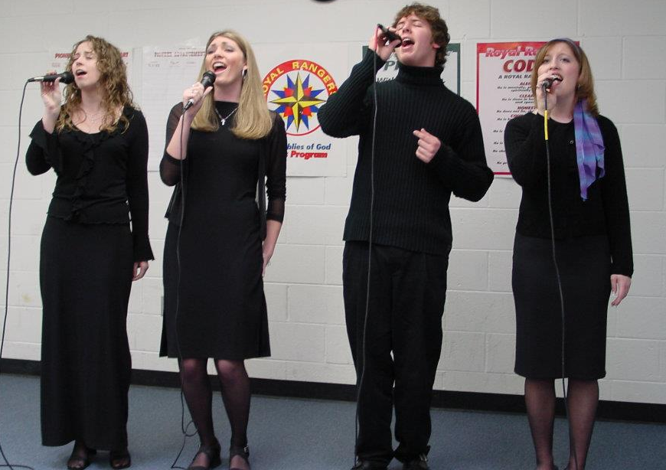
- We are cultivating next steps ministry wise: being an encouragement to those still in; finding ways to breathe life into local churches; giving pastor’s a break; and more to come!

2. Jeff & Dawn Bullard

(5 daughters, 2 sons-in-law, 3 grandsons, 2 granddaughters)
Mackenzie & Andrew Miller (Kai, Ellie, Koa)
Alexandra & Jordan Foudray (Halston, Milo)
Kylie
Madelynn
Arianna

3.Pastor Devin & Jenny Galloway

4..Pastor Devin & Jenny Galloway

5. what if…

6.
Hebrews 11-NKJV
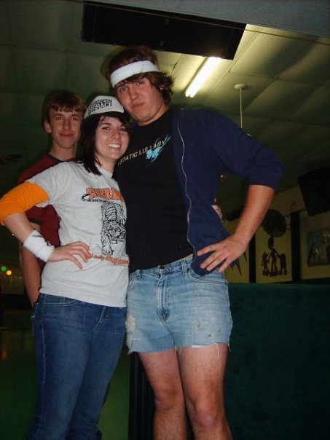
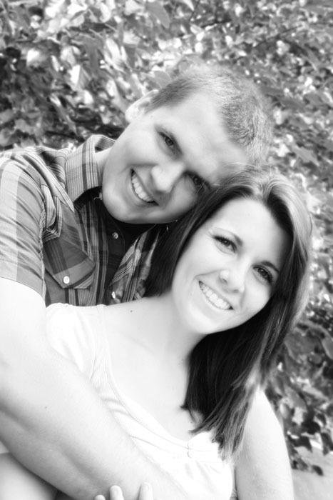
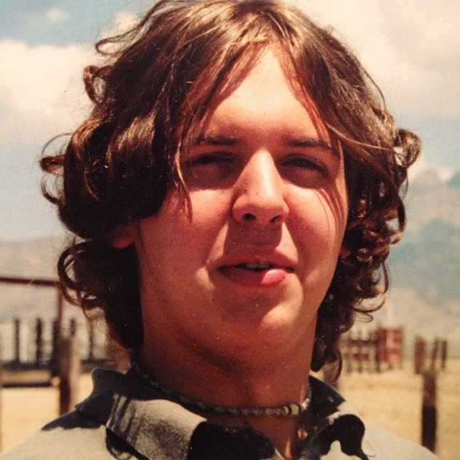
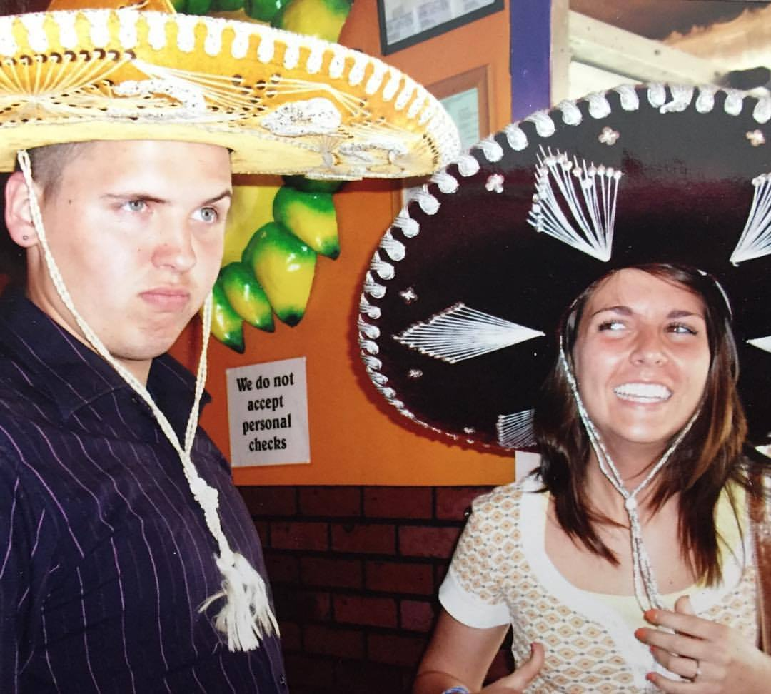
1 Now faith is the substance of things hoped for, the evidence of things not seen. 2 For by it the elders obtained a good testimony.
3 By faith we understand that the]worlds were framed by the word of God, so that the things which are seen were not made of things which are visible.

7.
Hebrews 11-NLT
1 Faith shows the reality of what we hope for; it is the evidence of things we cannot see. 2 Through their faith, the people in days of old earned a good reputation.
3 By faith we understand that the entire universe was formed at God’s command, that what we now see did not come from anything that can be seen.

8.
Hebrews 11-NIV
1 Now faith is confidence in what we hope for and assurance about what we do not see. 2 This is what the ancients were commended for.
3 By faith we understand that the universe was formed at God’s command, so that what is seen was not made out of what was visible.

9.
we face what if…

in 2 main places IMPOSSIBLE (this week)
ORDINARY (next week)

10.
When contemplating the WHAT IF’s…

“The impossible looks like odds that are stacked against you, or being willing to take a RISK”

“The ordinary looks like just keep taking the next step”

11.
Identify a moment in your life you had to face
WHAT IF:

…for life’s circumstances
…in important life decisions

12.
Matthew 19-NIV
26 Jesus looked at them and said, “With man this is impossible, but with God all things are possible.”

13.
Ephesians 3-NIV
14 For this reason I bow my knees to the Father of our Lord Jesus Christ, 15 from whom the whole family in heaven and earth is named, 16 that He would grant you, according to the riches of His glory, to be strengthened with might through His Spirit in the inner man, 17 that Christ may dwell in your hearts through faith; that you, being rooted and grounded in love, 18 may be able to comprehend with all the saints what is the width and length and depth and height—

14.
Ephesians 3-NIV
19 to know the love of Christ which passes knowledge; that you may be filled with all the fullness of God.
20 Now to Him who is able to do exceedingly abundantly above all that we ask or think, according to the power that works in us, 21 to Him be glory in the church by Christ Jesus to all generations, forever and ever. Amen.

15.
where are your “what if’s” taking you today?

16. (Build out bullets)
Impossibilities in Life Circumstances
- Illnesses-Divine healing
- People & Relationships
- Financial
- Miracles
- Heart and Soul
- Brokenness & Difficulty of any kind

17. (build out bullets)
Impossibilities in Life Decisions
- That dream that God has placed in your heart
- That class or degree you’ve been contemplating
- That life ministry, investment you’ve been apprehensive to take
- Breaking out of the norm
- That difficult/hard thing
- Risk/Step of Faith

18.
How we respond to the IMPOSSIBLE What If’s

19.
Our History
Habakuk 3-NKJV
2 Lord, I have heard of your fame;
I stand in awe of your deeds, Lord.
Repeat them in our day,
in our time make them known;
in wrath remember mercy.
Psalm 100-NKJV
5 For the Lord is good and his love endures forever;
his faithfulness continues through all generations.

20.
Our Authority
Matthew 8-NIV
5 Now when Jesus had entered Capernaum, a centurion came to Him, pleading with Him, 6 saying, “Lord, my servant is lying at home paralyzed, dreadfully tormented.”
7 And Jesus said to him, “I will come and heal him.”
8 The centurion answered and said, “Lord, I am not worthy that You should come under my roof. But only speak a word, and my servant will be healed.

21.
Our Authority
Matthew 8-NIV
9 For I also am a man under authority, having soldiers under me. And I say to this one, ‘Go,’ and he goes; and to another, ‘Come,’ and he comes; and to my servant, ‘Do this,’ and he does it.”
10 When Jesus heard it, He marveled, and said to those who followed, “Assuredly, I say to you, I have not found such great faith, not even in Israel! 13 Then Jesus said to the centurion, “Go your way; and as you have believed, so let it be done for you.” And his servant was healed that same hour.

22.
Our Authority
Matthew 28-NIV
18 Then Jesus came to them and said, “All authority in heaven and on earth has been given to me. 19 Therefore go and make disciples of all nations, baptizing them in the name of the Father and of the Son and of the Holy Spirit, 20 and teaching them to obey everything I have commanded you. And surely I am with you always, to the very end of the age.”

23.
Our Authority
Ephesians 1-NIV
18 I pray that the eyes of your heart may be enlightened in order that you may know the hope to which he has called you, the riches of his glorious inheritance in his holy people, 19 and his incomparably great power for us who believe. That power is the same as the mighty strength 20 he exerted when he raised Christ from the dead and seated him at his right hand in the heavenly realms,

Romans 8:11 “the same Spirit that raised Christ from the dead now lives in you

24.
Our Words
Ezekiel 37-NIV
1 The hand of the Lord was on me, and he brought me out by the Spirit of the Lord and set me in the middle of a valley; it was full of bones. 2 He led me back and forth among them, and I saw a great many bones on the floor of the valley, bones that were very dry. 3 He asked me, “Son of man, can these bones live?”
I said, “Sovereign Lord, you alone know.”

25.
Our Words
Ezekiel 37-NIV
4 Then he said to me, “Prophesy to these bones and say to them, ‘Dry bones, hear the word of the Lord! 5 This is what the Sovereign Lord says to these bones: I will make breath enter you, and you will come to life. 6 I will attach tendons to you and make flesh come upon you and cover you with skin; I will put breath in you, and you will come to life. Then you will know that I am the Lord.’”
7 So I prophesied as I was commanded. And as I was prophesying, there was a noise, a rattling sound, and the bones came together, bone to bone. 8 I looked, and tendons and flesh appeared on them and skin covered them, but there was no breath in them.

26.
Our Words
Ezekiel 37-NIV
9 Then he said to me, “Prophesy to the breath; prophesy, son of man, and say to it, ‘This is what the Sovereign Lord says: Come, breath, from the four winds and breathe into these slain, that they may live.’” 10 So I prophesied as he commanded me, and breath entered them; they came to life and stood up on their feet—a vast army.

27.
Our Words
Proverbs 18-NIV

21 The tongue has the power of life and death,
and those who love it will eat its fruit.

28.
Our Obedience
I will talk about this component more next week!!!

29.
Our Courage
Luke 18-NIV
35 As Jesus approached Jericho, a blind man was sitting by the roadside begging. 36 When he heard the crowd going by, he asked what was happening. 37 They told him, “Jesus of Nazareth is passing by.”
38 He called out, “Jesus, Son of David, have mercy on me!”
39 Those who led the way rebuked him and told him to be quiet, but he shouted all the more, “Son of David, have mercy on me!”

30.
Our Courage
Luke 18-NIV
40 Jesus stopped and ordered the man to be brought to him. When he came near, Jesus asked him, 41 “What do you want me to do for you?”
“Lord, I want to see,” he replied.
42 Jesus said to him, “Receive your sight; your faith has healed you.” 43 Immediately he received his sight and followed Jesus, praising God. When all the people saw it, they also praised God.

31.
Our Courage
Matthew 14-NIV
28 “Lord, if it’s you,” Peter replied, “tell me to come to you on the water.”
29 “Come,” he said.
Then Peter got down out of the boat, walked on the water and came toward Jesus.

32.
“No one that is ever worried about what people think of them will ever be able to succeed in the IMPOSSIBLE, “what if” places of life”

33.
“Faith filled prayers and risk takers will often seem audacious and arrogant to the faithless and institution of religion… do it anyways!”

34
“In other words, people believing and moving towards living in the IMPOSSIBLE “What If’s” will ever be intent on saving their reputation”
example: Noah

35
1 Chronicles 4-NKJV
9 Now Jabez was more honorable than his brothers, and his mother called his name Jabez, saying, “Because I bore him in pain.” 10 And Jabez called on the God of Israel saying, “Oh, that You would bless me indeed, and enlarge my territory, that Your hand would be with me, and that You would keep me from evil, that I may not cause pain!” So God granted him what he requested.

36
How we respond to the IMPOSSIBLE What If’s
- OUR HISTORY
- OUR AUTHORITY
- OUR WORDS
- OUR OBEDIENCE
- OUR COURAGE

37.
- What Life Circumstances “what if’s” are you facing today?
- What Life Decisions “what if’s” are you facing today?
- Will you believe for the impossible?

38
Ephesians 3-NKJV

20 Now to Him who is able to do exceedingly abundantly above all that we ask or think, according to the power that works in us,

