Series: Speak Life (The Power of Blessing)
Series Text: 1st Peter 3:9
September 23, 2018
Message 3:
How Can I Bless God?

Guests - Handout designed with you in mind - Info and notes especially for you - won’t call or visit -

Next Steps

Generosity

Notes on Handout and in YouVersion App

1st Peter 3:9 MSG - … bless—that’s your job, to bless. You’ll be a blessing and also get a blessing.

Part 1 - Speak blessings over our family and their future!

- We not only need to learn to speak blessings - we need to learn to seek blessings.
- When we bless our families, we inspire them to seek the blessing of God even more!

Part 2 - Speak blessings over your situations and circumstances!

Today:

Big Idea: You can bless God!

How can I bless God? Doesn’t He have everything already?

Does He have your life?
Does He have your constant praise?
Does He have a life of gratitude and blessing from you?

Psalm 103 Message - O my soul, bless God.
From head to toe, I’ll bless his holy name!
O my soul, bless God,
don’t forget a single blessing!

He forgives your sins—every one.
He heals your diseases—every one.
He redeems you from hell—saves your life!
He crowns you with love and mercy—a paradise crown.
He wraps you in goodness—beauty eternal.
He renews your youth—you’re always young in his presence.

God makes everything come out right;
he puts victims back on their feet.
He showed Moses how he went about his work,
opened up his plans to all Israel.
God is sheer mercy and grace;
not easily angered, he’s rich in love.
He doesn’t endlessly nag and scold,
nor hold grudges forever.
He doesn’t treat us as our sins deserve,
nor pay us back in full for our wrongs.
As high as heaven is over the earth,
so strong is his love to those who fear him.
And as far as sunrise is from sunset,
he has separated us from our sins.
As parents feel for their children,
God feels for those who fear him.
He knows us inside and out,
keeps in mind that we’re made of mud.
Men and women don’t live very long;
like wildflowers they spring up and blossom,
But a storm snuffs them out just as quickly,
leaving nothing to show they were here.
God’s love, though, is ever and always,
eternally present to all who fear him,
Making everything right for them and their children
as they follow his Covenant ways
and remember to do whatever he said.

God has set his throne in heaven;
he rules over us all. He’s the King!
So bless God, you angels,
ready and able to fly at his bidding,
quick to hear and do what he says.
Bless God, all you armies of angels,
alert to respond to whatever he wills.
Bless God, all creatures, wherever you are—
everything and everyone made by God.

And you, O my soul, bless God!

You can bless God!

We are commanded to bless God!

And - when we start blessing God - there are all kinds of benefits that come our way!

Job’s wife, “Curse God and die!”

I wouldn’t advise that!

Here’s why you should bless God:

> He forgives your sins - every one!

Our biggest problem is a heart problem -

Jeremiah 17:9 - The human heart is the most deceitful of all things, and desperately wicked. Who really knows how bad it is?

We have a sin problem. We are born into sin - we are born with a desire to sin - and until we surrender our lives to Jesus, we are controlled by sin.

Only the power that raised Jesus from the dead can change and fix this broken heart - Our hearts are the most deceitful things on the earth - they even deceive us - because we begin to think we’re not so bad.

Here’s what you need to do to have your heart healed - you need to bless God!

“I bless you God because you have extended to me so much mercy. I bless you God because you have unlimited grace! It never runs out! You are always wanting to forgive me and bring me into a great relationship with you! I bless you God because your Son, Jesus, came to this earth and was torn apart on a cross and died as punishment for my sin! I deserved the cross - but Jesus took it in my place - so I will bless you God! I bless you God for the Holy Spirit who applies that blood of Jesus to my life! I bless you Lord for thinking of me and loving me even when I was active in my sin and actively pursuing sin! I bless you God because you loved me when I cursed you! Thank you Lord for saving me and offering me forgiveness and salvation from eternal punishment! ! I bless you God!”

> He heals your diseases - every one!

Some may question this right away - I understand - my son has Crohn’s Disease - it is a struggle …

But the Bible tells me that Jesus is our Healer!

Jehovah-Rophe - So I pray and thank Him for being my Healer - our healer - Sharon’s healer - Kyle & Anna’s healer - and Randy’s healer!

He is already Randy’s healer - He doesn’t have to become Randy’s healer - he already is Randy’s healer - He already did the work for Randy’s healing.

I am not confessing something that doesn’t exist - Randy has Crohn’s Disease - but God is already His healer! I am blessing God for Jesus being the Healer … and asking for that healing work to take place in Randy -

And if it doesn’t - it doesn’t change the fact that Jesus did the work for his healing -

Does my son deserve His healing? No.
Have I done anything for my son to deserve healing? No.

But God chose to send His Son to the cross to be beaten for our healing - so that has already been done.

Until we see that healing take place - we will bless God for being the healer - and we will bless God for the positive changes that have taken place in Randy’s life - and the growth in his faith that has taken place in the face of this difficulty - because God is a good God - He knows what is best for us - and He is our Healer -

I’ve seen Him heal in this life - I’ve seen Him wait to heal until the next life - but He never fails to heal those who believe in Him!

I will bless God because He heals our diseases - every one!

> He redeems you from hell - saves your life!

Satan is the destroyer! Jesus has purchased us from the power and possession of Satan with His own blood!

When Satan comes to attack me and destroy me - I’m going to bless God for being the one who bought me back from him!

Whatever pit you think you are in - God is the one who brings you out of the pit!

Psalm 40:2-3 - He lifted me out of the pit of despair,
out of the mud and the mire.
He set my feet on solid ground
and steadied me as I walked along.
He has given me a new song to sing,
a hymn of praise to our God.
Many will see what he has done and be amazed.
They will put their trust in the Lord.

> He wraps you in goodness - beauty eternal.

Bless God because He takes the edge off! He takes away nervousness and fear. He takes away tension and temper! He takes away our critical spirit! He takes away our lack of compassion and fills us with love!

> He renews your youth - you’re always young in his presence!

Like the renewal of the eagle’s wings and talons - God renews your strength! If you bless God in your weariness, He will give you strength!

Even when the body gets old and tired, our spirits can remain young and strong - and full of faith!

We’ve talked about blessing our families - our situations - and blessing God -

Here is how God told Moses to have the priests bless the people:

Numbers 6:22-27 - Then the Lord said to Moses, “Tell Aaron and his sons to bless the people of Israel with this special blessing:
‘May the Lord bless you and protect you.
May the Lord smile on you and be gracious to you.
May the Lord show you his favor and give you his peace.’
Whenever Aaron and his sons bless the people of Israel in my name, I myself will bless them.”

The priests were to give these blessings -

1st Peter 2:9 - …you are a chosen people. You are royal priests,
a holy nation, God’s very own possession. As a result, you can show others the goodness of God, for he called you out of the darkness into his wonderful light.

As priests - we have been given this power to bless.

God said to Moses, “This is how you are to bless the people - you are not to curse - you are to bless -

> May the Lord bless and protect you.

Who doesn’t need the blessing and protection of the Lord?

> May the Lord smile on you and be gracious to you.

Our world needs more of God’s smiles - and we are the ones commissioned to give the world God’s smiles - it wouldn’t hurt if we would start right here with one another - in our homes - in our workplaces - share the smiles of God.

A yearbook - “Do you ever stop smiling?”

Was I really like that? I don’t feel like I’ve been like that for a long time - but we’ve been called to bless people with the smiles of God.

> May the Lord show you his favor and give you his peace.

I want the favor of God. I need the favor of God - everyone I know needs the favor of God! If I have received His favor - I need to bless others with His favor!

This gives us peace!

John 14:27 NIV - Peace I leave with you; my peace I give you. I do not give to you as the world gives. Do not let your hearts be troubled and do not be afraid.

Philippians 4:7 - …God’s peace… exceeds anything we can understand. His peace will guard your hearts and minds as you live in Christ Jesus.

Let’s be the priests of our homes -

Gather your children together - young or old - open this Scripture - place your hands on them - and speak this over their lives -

God says He will bless them! Men - lay your hands on your wives to pray for them and bless them! Parents, before your kids go to the ball game, or school, or the band concert, lay your hands on them, pray for them and bless them in the name of Jesus!

“That’s too spiritual - I don’t want my kids growing up weird!” What’s the alternative to being spiritual? What’s the alternative of not blessing them? You’d better start blessing them!

A young man once went to his daddy - The young man was a Christian - the father was not. The young man said, “Dad, I want you to bless me!” Now, most men don’t like to get mushy - it’s hard for us to do -

The young man said, “Dad, I want you to bless me!” The Dad said, “Well, I don’t know how to do that! I don’t know what to say!” The son said, “Well Dad, I’ll just pull up a chair and you just say what you wish for me and my family.”

The boy pulled up the chair and said, “Just say what you would like to see happen in me and my family’s life.”

The Dad opened his mouth and began to say what he wished upon his boy, and the wife and grandchildren. Words started to come, tears started to flow. It was like the anointing came upon his Dad. That day that father and son were bound together until the day the father died.

I don’t completely understand how a person can bless someone and it comes to pass, but it woks! I’ve practiced this, and I’ve seen it happen!

David brought the ark of God home …

Danced …

2nd Samuel 6:17-20 - They brought the Ark of the Lord and set it in its place inside the special tent David had prepared for it. And David sacrificed burnt offerings and peace offerings to the Lord. When he had finished his sacrifices, David blessed the people in the name of the Lord of Heaven’s Armies. Then he gave to every Israelite man and woman in the crowd a loaf of bread, a cake of dates, and a cake of raisins. Then all the people returned to their homes.
When David returned home to bless his own family, Michal, the daughter of Saul, came out to meet him. She said in disgust, “How distinguished the king of Israel looked today, shamelessly exposing himself to the servant girls like any vulgar person might do!”

He goes home to bless his family - and he runs into a windstorm! Cursing from his wife.

When you set out to live this lifestyle of blessing - and speaking blessings over others - you will face opposition - there will be a spiritual fight. Don’t give in! Don’t give up!

If you know that Satan doesn’t want you to do something - grit your teeth and do it all the more!

David died - Solomon took over -

1st Kings 8:14-15 - Then the king turned around to the entire community of Israel standing before him and gave this blessing: “Praise the Lord, the God of Israel, who has kept the promise he made to my father, David.”

You start doing this - and the blessings can continue from generation to generation to generation to generation.

Pictures …

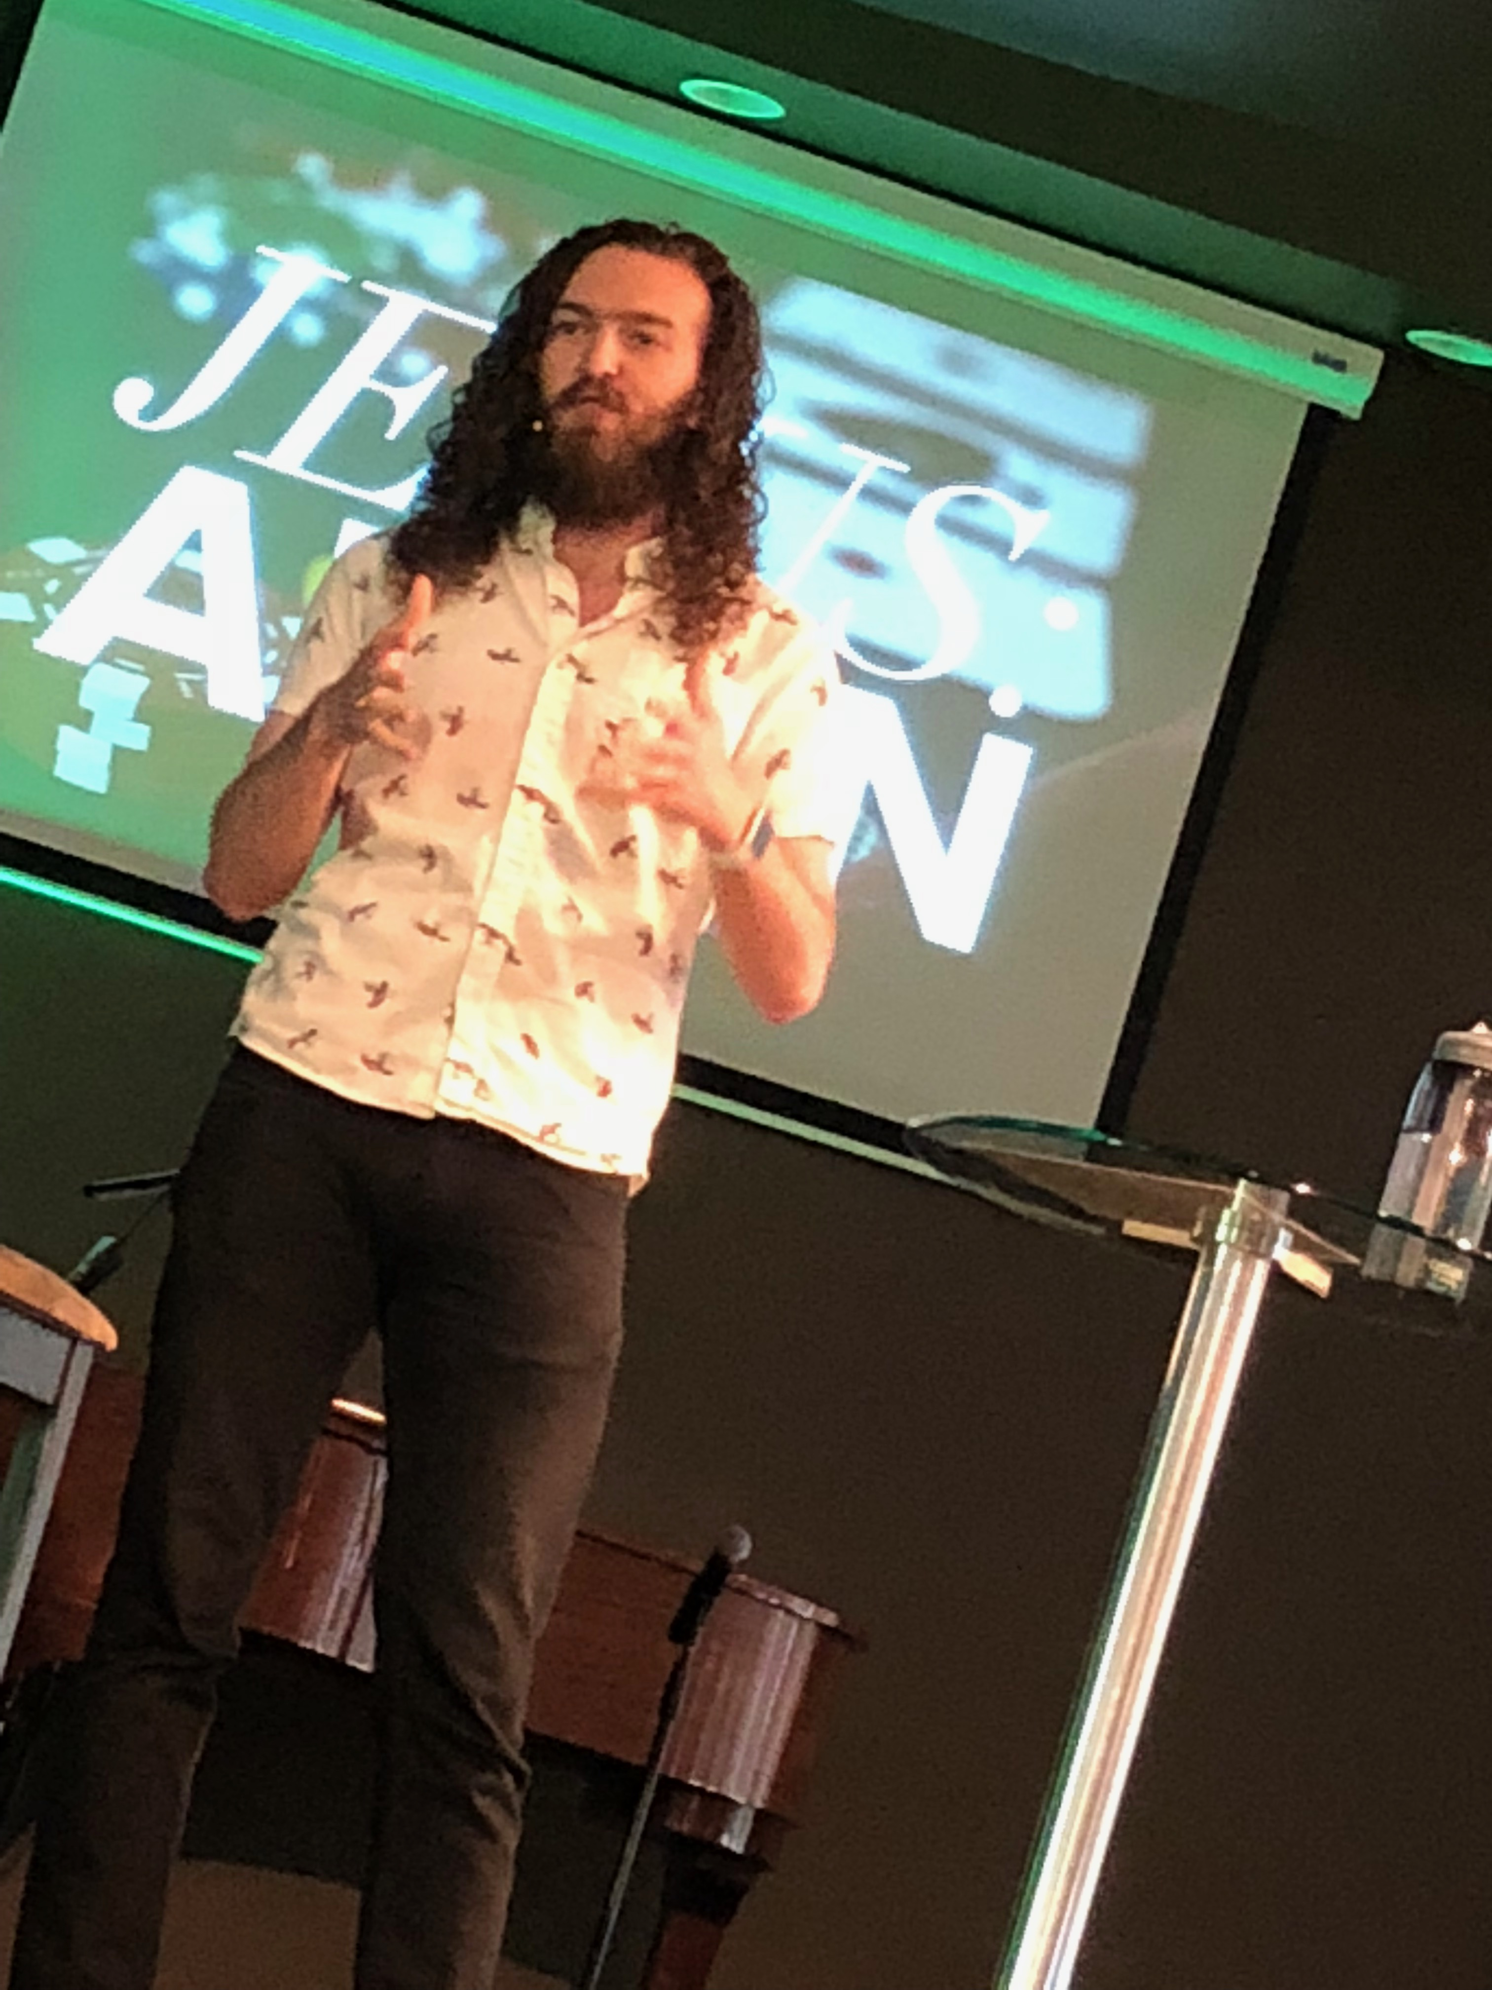
(Put the above 3 of Kyle, Anna & Randy on the same slide please.)

(Repeat original picture of Great-grandad) …

There’s so much more I could say about all of this - This series could have been much longer - many more Scriptures - many more messages -

But here’s my prayer and blessing - may God bless you to become a blessing.
- May God teach you - may the Holy Spirit teach you - to speak words of blessing over your family - your spouse - your children - your grandchildren. May you have a DESIRE to bless - to be a blessing - to speak words of blessing over your family - your co-workers - your jobs - your situations - your finances -
- May you have the faith to believe and know that your words of blessing are not just words and wishes - but that your words of blessing will come to pass!
And may your life and your words - BLESS GOD!
May the Lord bless you and protect you.
May the Lord smile on you and be gracious to you.
May the Lord show you his favor and give you his peace.

