2nd Corinthians
Series: Relentless
June 3, 2018
Message 1:
It’s Complicated!
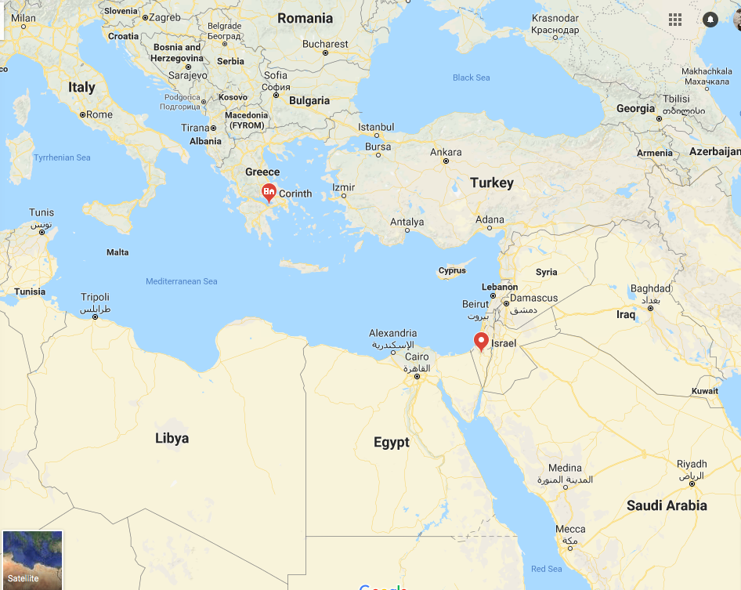
2nd Corinthians 1:1-11
Intro: The city of Corinth was a very busy port city - lots of traffic - lots of commerce - lots of trade - business people and military people coming and going regularly in and out of the city - known to be extremely wicked - arrogant - intellectual - wealthy.

Chief worship - Aphrodite - the goddess of love - they had “consecrated” prostitutes.

In the ancient world, and still in the pagan world today, the worship of idols often involves sexuality and the practice of sexual relationships with pagan prostitutes at the shrines is considered to be an act of worship that somehow brings blessing to crops and businesses. That’s an interesting way to justify all kinds of sexual sin.

In the famous and ancient Iliad of Homer, the city is referred to as “wealthy Corinth”. The city developed such a reputation for sexual wickedness that a person could be called a “Corinthian” without being from Corinth or having ever been there - to be a “Corinthian” became the label for anyone who was an openly and consistently involved in sexual sin.

So Paul went to Corinth to bring these people to Jesus! It’s interesting that today our prevailing culture has adopted these practices that the Bible considers sin as being normal, even though they are still destructive. God’s way of living may not be easy in terms of being in the minority in culture today, but it certainly does lead to a better way of life and helps us to avoid a lot of pain. But our culture has pretty much accepted and become saturated with the same kind of life destroying lifestyles - and just like Paul it is into our culture that we must bring the light of Jesus - speaking the truth in love.

Acts 18:1-16 -

Paul travels from Athens to Corinth - meets Priscilla and Aquilla - Jewish Christians who had been kicked out of Rome in a persecution of the Jews by Claudias Caesar -

They started a tent making business together and Paul began to teach about Jesus in the Jewish synagogue. This wasn’t accepted - so Paul left the synagogue and started holding meetings right next door to tell the Gentiles (pagans) about Jesus. The leader of the synagogue converted - everyone in his house began to follow Jesus - and then many others believed and were baptized! This is a tremendous miraculous start for a church!

“One night the Lord spoke to Paul in a vision and told him, “Don’t be afraid! Speak out! Don’t be silent! For I am with you, and no one will attack and harm you, for many people in this city belong to me.” So Paul stayed there for the next year and a half, teaching the word of God.”

But then the Jews in the community came against him - arrested him and brought him to the governor of the area - but right in line with what God had told Paul, the governor of the area threw out the case - Paul stayed just a little while longer and determined it was time for him to move on to other places and leave the church in the hands of other leadership.

Some time after Paul left many began to live lives of sin again, but stayed in the church - then they justified and spiritualized their sin as being ok. But going against God’s plan will lead to pain in life! He created us so He knows what is best for us!

So the people in Paul’s church were claiming to be Christians, but living sinful lifestyles - no different from the rest of the city. The people justified themselves as being smarter and more spiritual than the Apostle Paul - and they had other visiting ministers who came through claiming to be greater apostles than Paul - and the church bought into anything which would allow them to sin and still be considered Christians - very dangerous - and it grieved Paul deeply!

The church began to develop a theology that allowed them to sin and they spiritually defended it!

Have you ever asked someone about a relationship they might have with a spouse - or boyfriend or girlfriend - or parents - and they say, “It’s complicated!”

That describes the relationship between Paul and this church!

Paul wrote more than 2 letters to this church - Paul was often in contact with this church because it was one of his “babies” - he was the leading Apostle responsible for its founding and care - and they needed a lot of correction!

1st Corinthians refers to a previous letter - so our “1st Corinthians” is actually 2nd Corinthians - and our 2nd Corinthians mentions a “severe and painful” letter which was written in between our 1st & 2nd Corinthians” - which would actually make that lost letter 3rd Corinthians - and so our 2nd Corinthians is actually 4th Corinthians - and some believe that our 2nd Corinthians is actually a compilation of 2 letters - which would make our 2nd Corinthians 4th & 5th Corinthians!

How do you like that?

If you’re confused - don’t worry - I’m a little confused myself! But accept this - 2nd Corinthians is at least the 4th letter Paul wrote to this church - and we still have these words because they are inspired by the Holy Spirit - the Holy Spirit has preserved them through the ages - because they have something to say to us today!

In 1st Corinthians, Paul attempted to reassert his authority as an Apostle and bring correction to many errors that were hindering them from bringing more people into a relationship with Jesus!

When Paul wrote 1st Corinthians he had to address the fact that they were getting drunk at the Lord’s Supper and letting the poor go hungry! There was a case in the church of a leader involved in a sexual relationship with his father’s wife. Members of the church were suing one another. They were appearing to be used in spiritual gifts, but it was not glorifying God, they were only attempting to make themselves look more spiritual than one another. Some were denying the truth of the resurrection - and they were openly opposing the authority of the Apostle Paul. So, Paul wrote what we have as 1st Corinthians to address much of this damage.

It wasn’t successful. (Imagine that - people not paying attention to the pastor’s advice!) So in between our 1st and 2nd Corinthians Paul planned to visit them in person, but he heard that things were so bad, he decided to write them another letter instead - this is the lost letter between 1st & 2nd Corinthians that is referred to as “severe and painful”. Both Timothy and Titus visited Corinth in the meantime - Titus delivered the difficult letter that we no longer have - and brought back an encouraging report (2nd Corinthians 7:8) - but word got back again to Paul that they were back to their old ways. So Paul made the personal visit he had previously planned - and that was a difficult and painful visit (2nd Corinthians 2:1-2)!

After this time together, people in the church were still rebelling against Paul and challenging his authority and teachings. This is when he writes our 2nd Corinthians in preparation for yet another trip to them.

So this letter is written after much rebellion and many attempts to correct it! In this letter he writes about suffering - because people were saying Paul couldn’t be an apostle if he suffered so much!

Isn’t this a common accusation today? “If you just had enough faith you wouldn’t be having such a hard time!” It is exactly that theology that attacked Paul himself - and it is that theology that Paul attacks in this letter saying that our sufferings show that we are identified with Christ who suffered for us!

It is unfortunate that Paul had to state clearly that if people were rejecting him and his message, they were rejecting Christ Himself as well!

All of this is happening in the mid-50’s A.D. - about 25 years after Jesus’ ministry, crucifixion and resurrection -

There are many ways to break this letter down - originally there were no chapter and verse divisions - it doesn’t flow very smoothly because Paul is dealing with so many problems and bringing much of his personal experience into the writing - so we are just going to look at it mostly chapter by chapter so you will see the themes flow together from week to week -

We have Paul’s opening greeting in verses 1 & 2 -

2nd Corinthians 1:1-2 - This letter is from Paul, chosen by the will of God to be an apostle of Christ Jesus, and from our brother Timothy.
I am writing to God’s church in Corinth and to all of his holy people throughout Greece.
May God our Father and the Lord Jesus Christ give you grace and peace.

Big Idea: There is a reason for hard times.

T.S.: Two truths from this opening passage:

> We suffer so that we can comfort.

2nd Corinthians 1:3-5 MSG - All praise to the God and Father of our Master, Jesus the Messiah! Father of all mercy! God of all healing counsel! He comes alongside us when we go through hard times, and before you know it, he brings us alongside someone else who is going through hard times so that we can be there for that person just as God was there for us. We have plenty of hard times that come from following the Messiah, but no more so than the good times of his healing comfort—we get a full measure of that, too.

Keep in mind the back story here - The church was being convinced that Paul could not be a great spiritual apostle and church leader because he went through too many hard times - too many difficulties - too many hardships - surely God’s blessing is not on a person who goes through hard times!

Paul is exposing this as a lie!

  - God comforts us so that we can comfort others.

This is a logical argument.

If we never suffered - if we never went through hard times - we would never know the comfort of God - This is one of the chief reasons God sent the Holy Spirit! Jesus called Him the Comforter!

How are we going to know the comfort of God unless we go through hard times ourselves?

These hard times are not due to sin - they are hard times due to faithfulness - and sometimes just due to the fact that we live in a fallen, broken world!

In fact, Paul says, the more we suffer the more God will shower us with his comfort through Christ!

The way Paul writes, suffering is actually a blessing from God, for without it we could not be showered with God’s comfort!

And once we experience the comfort of God - we can comfort others!

SMALL GROUPS!!

“One another” verses …

Just one - Hebrews 10:24 - Let us think of ways to motivate one another to acts of love and good works.

2nd Corinthians 1:6 - Even when we are weighed down with troubles, it is for your comfort and salvation!…

Paul is writing, “You think I’m not an apostle, I don’t have authority, and I can’t be your leader because I’m going through hard times? These hard times I’m going through are specifically for you!

There is a kind of suffering in leadership that only comes to leadership - and it is for the sake of those who are led.

Selah …

2nd Corinthians 1:6-7 - For when we ourselves are comforted, we will certainly comfort you. Then you can patiently endure the same things we suffer. We are confident that as you share in our sufferings, you will also share in the comfort God gives us.

Paul says: “Guess what - I’m suffering so that I’ll have the ability to comfort you - because if you live for Christ - really live for Christ in this world - the same difficulties that are happening to me are going to happen to you! You can’t escape them!”

There are blessings for following Christ - and the blessings far outweigh the difficulties - but if we live right against the prevailing culture of this world, we will face difficulty for it.

If you’re not facing any difficulty for being a Christian, you might need to get a little more out of the closet.

Don’t invite trouble - just live for Jesus - don’t try to hide it - there will be opposition - but we go through the difficulty so that we can help others when it comes to them!

If you’re a seasoned believer and know what I’m talking about - find a new believer - take them under your wing - tell them your stories - and give them strength and encouragement!

> We suffer so that we learn to rely only on God.

2nd Corinthians 1:8-10 - We think you ought to know, dear brothers and sisters, about the trouble we went through in the province of Asia. We were crushed and overwhelmed beyond our ability to endure, and we thought we would never live through it. In fact, we expected to die. But as a result, we stopped relying on ourselves and learned to rely only on God, who raises the dead. And he did rescue us from mortal danger, and he will rescue us again. We have placed our confidence in him, and he will continue to rescue us.

Paul said, “There was a time back in Asia it got so bad I thought I was going to die! … crushed … overwhelmed … I knew I couldn’t make it on my own. I had to rely only on God.
“If God raises the dead, then He can help me in this crushing, seemingly impossible situation!”

Do you feel crushed today?

Meaning of gethsemane - “oil press” - … crushing of the olive … Jesus was crushed …

Isaiah 53:5 MSG - But it was our sins that did that to him,
that ripped and tore and crushed him—our sins!
He took the punishment, and that made us whole.

Do you feel like you are in an impossible situation today?

Jesus didn’t go through His suffering alone.

Paul didn’t go through His suffering alone.

You don’t have to go through your suffering alone.

All suffering is not because of sin and disobedience - sometimes we suffer even though we are living right - sometimes we suffer specifically because we are living right - but through it all - God is with us and we are in this together!

And Paul says, “I know He will do this again because He’s done this before!”

Every time God helps us through a bad situation it should give us confidence that He will be with us in the next bad situation!

- Through our difficulties we pray for one another.

2nd Corinthians 1:11 - And you are helping us by praying for us. Then many people will give thanks because God has graciously answered so many prayers for our safety.

Paul knows he has people in this church who are against him - yet he appeals to prayer.

Can we pray for one another even when we disagree with one another?

Won’t that praying for one another help dissolve our disagreements?

It’s hard to hate someone if you’re praying for them!

And many others will give thanks to God when they see Him answering our prayers for one another in our struggles!

** We’re calling this series “Relentless” - because in these passages we see Paul relentlessly pursuing God’s plan for His life, and relentlessly pursuing the purpose of the Corinthian people not wasting the grace of God that they have received -

And we share this goal - to relentlessly pursue God’s plan - and relentless pursue those who need God’s grace.

